Ayrshire Archaeological and Natural History Society

SCOTTISH CHARITY NO. SC044758

ANNUAL REPORT & FINANCIAL STATEMENTS

FOR THE YEAR ENDED 31 JANUARY 2018

AYRSHIRE ARCHAEOLOGICAL AND NATURAL HISTORY SOCIETY 1.
TRUSTEES’ ANNUAL REPORT

FOR THE YEAR ENDED 31 JANUARY 2018

Management
The Committee, who are the Trustees for charity law, have pleasure in presenting the Report for the year ending 31st January 2018 as follows:

1. Contact and Address
c/o Ian Holland, 41 East Park Road, Ayr, KA8 9JF

2. Objectives
The Society's objectives are:

to promote an interest in heritage, culture and environment particularly of and within Ayrshire by:
- encouraging the study of these subjects and stimulating research;
- holding regular meetings and organising excursions;
- promoting the conservation of the heritage of Ayrshire;
- publishing regularly material related to these objectives;
- co-operating with any other organisation(s) as may be appropriate.

3. Constitution `
The Society is a Scottish Charity Number SC044758 and is governed by the constitution last revised and adopted at the Extraordinary General Meeting held on Thursday 9 October 2014.

4. Current Management Committee
Chair/President &Trustee Mr Rob Close
Vice President Mr Angus Rodger
Secretary & Trustee Mr Denis Rattenbury
Treasurer & Trustee Mr Ian Holland
Membership Secretary Mrs Merry Graham
Minutes Secretary Mrs Katherine Scott
Excursions Convenor Mrs Sandra Carolan
Lectures Secretary Mr Billy Young
Publications Convenor Mr Denis Rattenbury
Publications Committee Messrs Dane Love, Ian Riggans, Alastair Weir and Billy Young
Ordinary Members Mrs Marion Buchanan, Mrs Sheena Andrew and Messrs Dane Love,
Ian Riggans, and Alastair Weir

Members of the Management Committee are elected at the Annual General Meeting each year and a member can serve for a maximum period of three years before standing for re-election.

Mr Rob Close was co-opted to the Management Committee at the Meeting on 27 April 2017. He was then elected as President/Trustee to take the place of Ian Gardiner who stepped down from the committee.

At the Management Committee on 18 January 2018 Mr Denis Rattenbury was elected as Secretary/Trustee to replace Mrs Sheena Andrew who became an ordinary committee member.

AYRSHIRE ARCHAEOLOGICAL AND NATURAL HISTORY SOCIETY 2.
TRUSTEES’ ANNUAL REPORT (continued)

FOR THE YEAR ENDED 31 JANUARY 2018

5. Management
The Management Committee, who hold regular meetings, are responsible for the strategic direction and governance of the Society. They generally control the activities of the Society and have a general responsibility to safeguard the assets of the Society.

6. Activities
In order to achieve the Society’s aims, relevant lectures are held over the winter season, relevant excursions are held over the summer season and monographs are produced on relevant subjects. The latter are free to our members. The lectures and excursions are open to members of the public.

Monographs on topics relevant to Ayrshire are published at a rate of one minimum per year and are free to members.

“Ayrshire Notes” are published twice yearly in conjunction with Ayrshire Federation of Historical Societies and Kilmarnock and District History Group and are free to members.

7. Achievements and Performance
The slow upturn in membership continues and a successful Buchan Lecture in conjunction with the Society of Antiquaries of Scotland was held to celebrate The Year of History, Archaeology and Heritage and also the 70th anniversary of our Society. We moved to the main auditorium for the occasion and had an increased attendance by 30%, including some who had travelled a distance.. From this occasion we added a few new members.

We are receiving a positive response regarding the subject matters of the lectures, the standard of our publications and also the venues of the excursions.

We are now advertising through the Scottish Local History Forum and through Nielsen, our ISBN contact. And our sales have increased.

We have also attracted a new Institutional member because of the quality of our publications.

8. Financial Review
The main sources of our funding are from memberships and from sales of publications.

Receipts exceeded payments in the year by £1,214, increasing our total fund balances to £12,990.

We have a commitment to reducing where possible our expenditure. We continue to make a substantial saving (about £240) by the switching of our insurance from directly through and agent to through membership of the British Association for Local History. We also continue to save by handing out our communications at meetings or by hand delivering them. This amounted to around £125.

We at present operate only a current account with the Clydesdale Bank. However, the Treasurer is looking to find a suitable bank or the like with which to create a new deposit account.
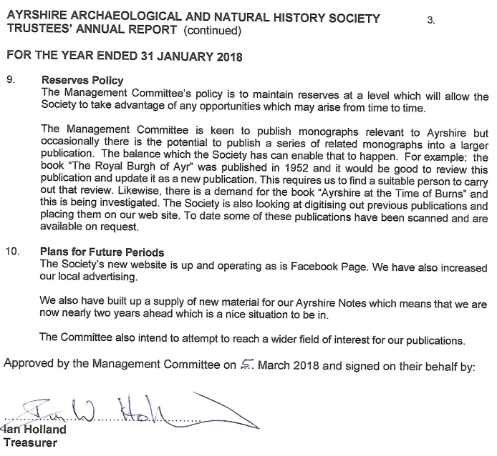

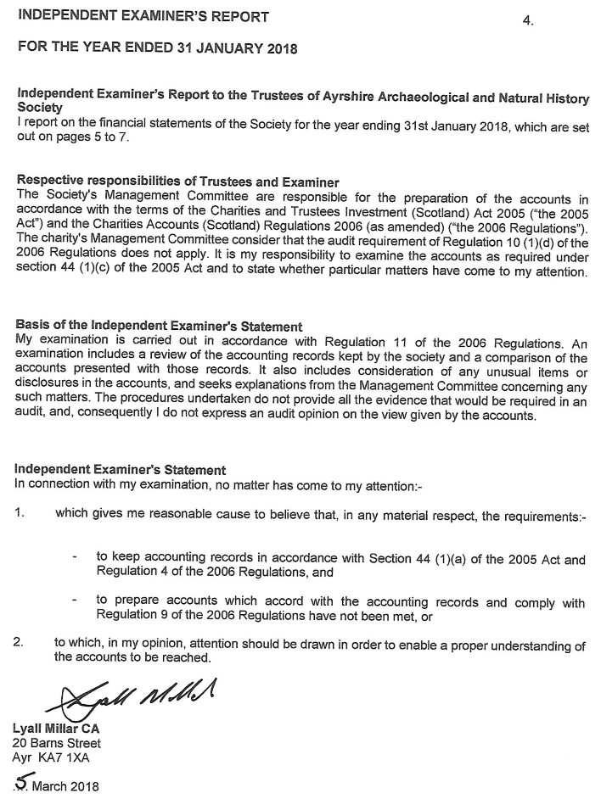

AYRSHIRE ARCHAEOLOGICAL AND NATURAL HISTORY SOCIETY 5.
STATEMENT OF RECEIPTS AND PAYMENTS

FOR THE YEAR ENDED 31 JANUARY 2018

 |  |  |  | Unrestricted Funds
 |  |  |  | 2017/18 |  | 2016/17
Receipts |  |  | Notes | £ |  | £
Voluntary Receipts
Donations |  |  |  | 353 |  | 31
Socials |  |  |  | 320 |  | 330
Bank Interest |  |  |  | 0 |  | 6
Receipts from Charitable Activities
Publication Sales |  |  |  | 972 |  | 1,790
Memberships |  |  |  | 2,608 |  | 2,640
Excursions |  |  |  | 1,243 |  | 1,195
Gift Aid |  |  |  | 498 |  | 724
 |  |  |  | 5.994 |  | 6,716
Payments
Cost of Charitable Activities |  |  | 3 | 4,580 |  | 4,832
Social Event |  |  |  | 200 |  | 200
Governance Costs |  |  | 4 | - |  | -
 |  |  |  | 4,780 |  | 5,032
Surplus for the year |  |  |  | 1,214 |  | 1,684
Receipts

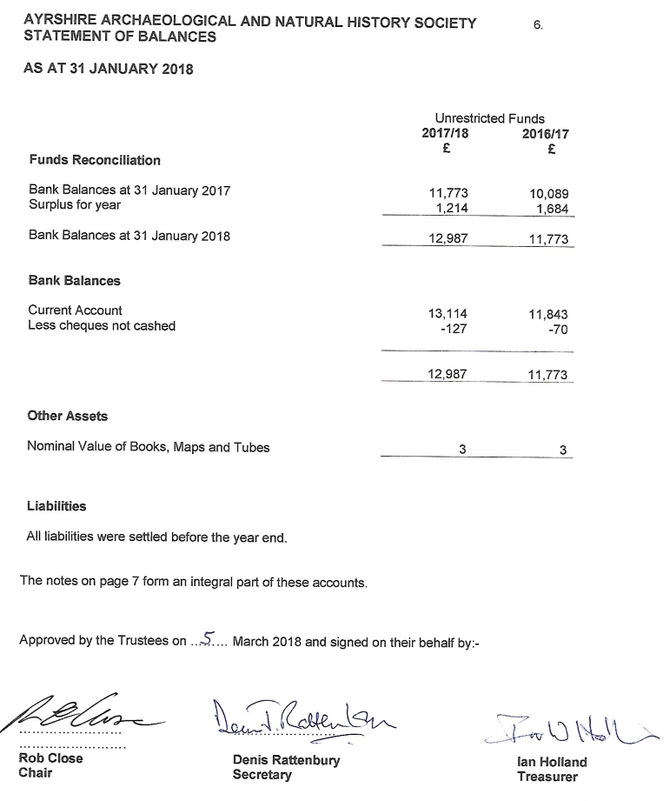

AYRSHIRE ARCHAEOLOGICAL AND NATURAL HISTORY SOCIETY 7.
NOTES TO THE ACCOUNTS

FOR THE YEAR ENDED 31 JANUARY 2018

- Basis of Accounting
These accounts have been prepared on the Receipts & Payments basis in accordance with the Charities & Trustee Investment (Scotland) Act 2005 and the Charities Accounts (Scotland) Regulations 2006 (as amended).

- Nature and purpose of funds
Unrestricted funds are those that may be used at the discretion of the trustees in furtherance of the objects of the charity.

Restricted funds may only be used for specific purposes. Restrictions arise when specified by the donor or when funds are raised for specific purposes.

In the Trustees’ opinion all funds are unrestricted.

- Cost of Charitable Activities
 | 2017/18 |  | 2016/17
 | £ |  | £
Excursions | 1,300 |  | 1,082
Printing, postage & stationery | 1.818 |  | 2,485
Hire of Hall/Room | 601 |  | 576
Lectures | 563 |  | 357
Subscriptions | 147 |  | 189
Miscellaneous Expenses | 151 |  | 143
 | 4.580 |  | 4,832

- Governance Costs
No charge has been made by the Independent Examiner.

