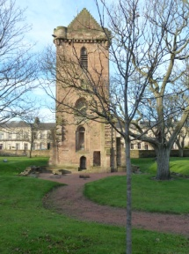
Ayrshire
Archaeological and Natural
History Society
Founded 1947
Scottish Charity No SC044758
Lectures…… Publications
Outings……..Socials
The Society St John’s Tower, Ayr
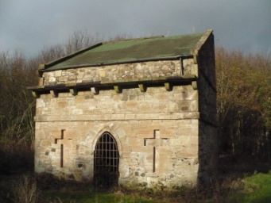
The specialist fields of interest are the archaeology, antiquities, local history and natural history of Ayrshire. Membership includes institutions, universities and libraries throughout Britain and the world.
Web Site: https://aanhs.org/
Email: info@aanhs.org Dovecot, Eglinton Park, Kilwinning
Facebook: https://www.facebook.com/theaanhs/
Would you like to become a member?
Membership is available to all who are interested in the activities of the Society. The new annual subscription rate is £20 for one, or £30 for a couple at the same address. If you have not yet decided whether or not to join, please come along to one of our meetings as our guest? Then if you wish to join, please complete the form below and either hand it to or mail it along with due subscription to:
Merry Graham, Membership Secretary, 27 Marchmont Road, Ayr, KA7 2SB.
Telephone 01292 267550.
Alternatively you can set up a Paypal subscription through our web site: https://aanhs.org/ or by BACS use “Ayrshire Archaeological & Natural History Society” a/c 00112208, s/c 826530 at Clydesdale Bank.
Please enrol me as a member of the Ayrshire Archaeological and Natural History Society for the year (1 September 2024 to 31 August 2025).
I enclose a cheque for £ payable to AANHS.
Name/s ___________________________________________
Address ___________________________________________
_________________________Post Code__________________
Email__________________________________Telephone_____________________
We would be grateful if you would consider completing the form below if you have not done so previously. It could mean something like an extra £500 per annum which will make a big difference to how many monographs that we can publish.
OPTIONAL GIFT AID DECLARATION
Please treat the enclosed subscription of £ as a Gift Aid donation. I confirm that I have paid or will pay Income Tax and/or Capital Gains Tax for this tax year (6 April to 5 April). I understand that the charity will reclaim 25p of tax for every £1 of the donation.
Name of Taxpayer _________________________________________
Signature of Taxpayer _____________________________Date__________________
Data Protection Act
This is an act which applies to businesses and organisations and therefore we have to comply. The only data which we have regarding our membership is:
- Name; Address; Telephone Number; Email Address (if it applies) and
Gift Aid declaration (if it applies).
This information will not be passed to any other body and will be deleted should a person cease to be a member of the Society.
Please complete the slip and return the form along with your membership application if you have not done so previously.

I am/we are willing/not willing for the Ayrshire Archaeological & Natural History Society to retain the information detailed above.

Signed……………………………………Print Name……………………………….

